**AI TRADING BOT**

**Prof. Nagashree K T *1, Shaik Arshiya*2, Sneha Nagaraj Shet*3, Vinutha S*4, Visharad Vidyasagar*5**

*1 Assistant Professor, Department of Information Science and Engineering, AMC Engineering College, Bengaluru, Karnataka, India.

*2345 Student, Department of Information Science and Engineering, AMC Engineering College,

Bengaluru, Karnataka, India.

**ABSTRACT**

The project "AI Trading Bot" is dedicated to creating a cutting-edge system that harnesses the power of machine learning and Artificial Intelligence to automate trading decisions within the stock market. By analyzing historical and real-time market data, the AI Trading Bot can identify patterns, forecast future trends, and execute trades with correctness.

The bot will analyze historical and real-time market data, identify patterns, predict future trends, and execute trades accordingly. The goal is to maximize profits while minimizing risk, outperforming traditional human trading strategies. The project will explore various AI techniques, including reinforcement learning and deep learning, and will evaluate their effectiveness in different market conditions. The AI Trading Bot has the potential to revolutionize the finance industry by making trading more efficient and accessible to everyone. This project will adhere to all ethical guidelines and regulations related to financial trading. The success of the project will be measured based on the bot’s performance in simulated and real-world trading scenarios. The project is expected to contribute significantly to the field of AI in finance.

This research presents a study on developing a model to enable AI-based trading bots to predict price components (open, high, low, and close prices) of the next 30-min, 1-h, and 4-h candlesticks for NASDAQ Market.

The significance of AI in trading lies in its ability to process vast amounts of historical and real-time data at speeds beyond human capacity. Machine learning algorithms within these bots can discern intricate patterns and trends, adapting strategies to changing market conditions. By harnessing computational power, AI trading bots aim to optimize trading outcomes, enhance portfolio management, and minimize emotional biases inherent in human decision-making.

**Keywords:** Artificial Intelligence (AI), National Association of Securities Dealers Automated Quotations (NASDAQ).

1. **INTRODUCTION**

The "AI Trading Bot" project explores the fusion of artificial intelligence and finance by designing a trading bot that leverages machine learning algorithms to make real-time trading decisions. The primary goals of this project include harnessing AI's predictive capabilities to analyze market trends, historical data, and live market changes, enabling autonomous trade executions for maximizing profits and minimizing losses.

In the ever-evolving landscape of financial markets, Artificial Intelligence (AI) trading bots have emerged as a transformative force, ushering in a new era of automated and data-driven decision-making. These sophisticated systems leverage advanced algorithms, machine learning, and real-time data analysis to navigate the complexities of trading with unparalleled efficiency and speed.

At its core, an AI trading bot is a computer program designed to execute buy or sell orders on financial instruments, such as stocks or cryptocurrencies, without direct human intervention. Unlike traditional trading methods, AI trading bots operate tirelessly, 24/7, analyzing market data, identifying patterns, and making split-second decisions based on predefined rules or learned behaviors.

The significance of AI in trading lies in its ability to process vast amounts of historical and real-time data at speeds beyond human capacity. Machine learning algorithms within these bots can discern intricate patterns and trends, adapting strategies to changing market conditions. By harnessing computational power, AI trading bots aim to optimize trading outcomes, enhance portfolio management, and minimize emotional biases inherent in human decision-making.

Key components of AI trading bots include algorithmic trading principles, machine learning models, data analysis techniques, and the integration of technical indicators. These components work in tandem to create a dynamic and responsive system capable of making informed decisions in highly volatile and competitive financial markets.

The advantages of AI trading bots extend beyond mere efficiency. These systems excel at back testing, allowing traders to evaluate historical performance and fine-tune strategies. Additionally, AI bots are inherently data-driven, relying on statistical analyses and mathematical models to inform trading decisions. This contrasts with human traders who may be influenced by emotions, cognitive biases, and limited processing capacities.

1. **METHODOLOGY**

Basic methodology we used to design the system to help traders in ai trading bot is LSTM, GOLDEN CROSS AND DEATH CROSS as a strategy.

Long Short-Term Memory (LSTM) is a type of Recurrent Neural Network (RNN) that is widely used in Deep Learning and excels at capturing long-term dependencies, making it ideal for sequence prediction tasks. LSTM is designed to deal with the vanishing gradient problem present in traditional RNNs. An LSTM network is composed of a cell, an input gate, an output gate, and a forget gate. The cell remembers values over arbitrary time intervals, and the three gates regulate the flow of information into and out of the cell.

A GOLDEN CROSS and DEATH CROSS are technical analysis indicators which can predict the trends in the market. A GOLDEN CROSS is a chart pattern that occurs when a short moving average is crosses above a relative long-term moving average. A DEATH CROSS is a opposite to the golden cross it occurs when a short moving average is crosses below a long-term moving average. Long-Short term Memory (LSTM) is a powerful tool which helps to improve the accuracy of the trading bot.

It helps in handling data in a sequential order, it incorporates a memory into a model structure which helps to compute multiple functions at every stage.it detects the trading signals, it prepares the data and utilizes the indicators for daily analysis, overall, it helps in the predictions .and maintains the bot accuracy and efficiency with better performance. This can be best strategy that helps the trading bot to provide best results.

**Building A Trading Bot**

Using the API, MT5 (META TRADER 5) a platform which allows the traders to do better technical analysis and it is multi assets platform with many advanced features. PINE CONNECTOR is acts as bridge which helps to connect metatrader5 and executes automatic alerts on it. Python is helps to provide the better results in developing the trading bot. Using python libraries like pandas, plotly, matplotlib, numpy makes the trading bot advanced and provides better efficiency and performance. Pine Script is a programming language developed by trading view. Using the pine script, we can develop the strategy, TICKER OR SYMBOL represents the stocks of a company.

**Working of the trading bot:**

The Real time data for a specific Ticker or Symbol (Stock Name), for a period of time is taken. The data is fetched using the MT5 of the IC Market broker. Pine connector is used to connect our code with the IC Market MT5, so that we can initialize the Market Trader automatically instead of opening it manually. The data retrieved can be of specific intervals, depending on the user’s need. The time interval can be for seconds, minutes, hours and days. These can be represented as 1 hour (H1), 2 hours (H2), 1 day (D1) to months (M1, M2, ….). The data is then loaded as per the need with all basic data like, time, open, close, high, low prices of the stocks. The working strategy for the bot is pretty easy and simple. The bot BUYS a stock, and then analyzes the data continuously, when the STOP LOSS or TAKE PROFIT is met, the bot SELLS the stock and completes a Trade. The same continues if the bot has already executed a BUY Trade, so it works on the LSTM conditions, to perform the next Trades. The bot starts to work automatically instead of doing everything manually. The bot will fetch data, buy, sell stocks on its own until the conditions are matched to do so.

The conditions for the TAKE PROFIT or STOP LOSS is done by using a user defined function, which checks for specific conditions to execute a Trade. The bot can work for n number of times, and on a user’s specific needs. Which allows the user to follow up their other works, rather than continuously checking the data every time manually and the bot can be put to sleep as per the user’s need as well. The bot will fetch data, buy, sell stocks on its own until the conditions are matched to do so. The conditions for the TP (take profit) or SL (stop loss) is done by using a user defined function, which checks for specific conditions to execute a Trade. The bot can work for n number of times, and on a user’s specific needs. Which allows the user to follow up their other works, rather than continuously checking the data every time manually. The bot can be put to sleep as per the user’s need as well.

1. **ARCHITECTURE**

The data flow model shows the working of the Trading bot and how it executes its trades. It starts taking the data in the real-time using the MT5 API, and then fetches and analyzes the data to get the price of the stocks at specific intervals of time. It analyzes the data and according to user input it can sell, buy, stop or take the conditions according to the decision made. Then the bot executed the trade in form of Buy, Sell, Take Profit or Sell Profit to complete the trade and it keeps on running and ends once the conditions to execute becomes false.

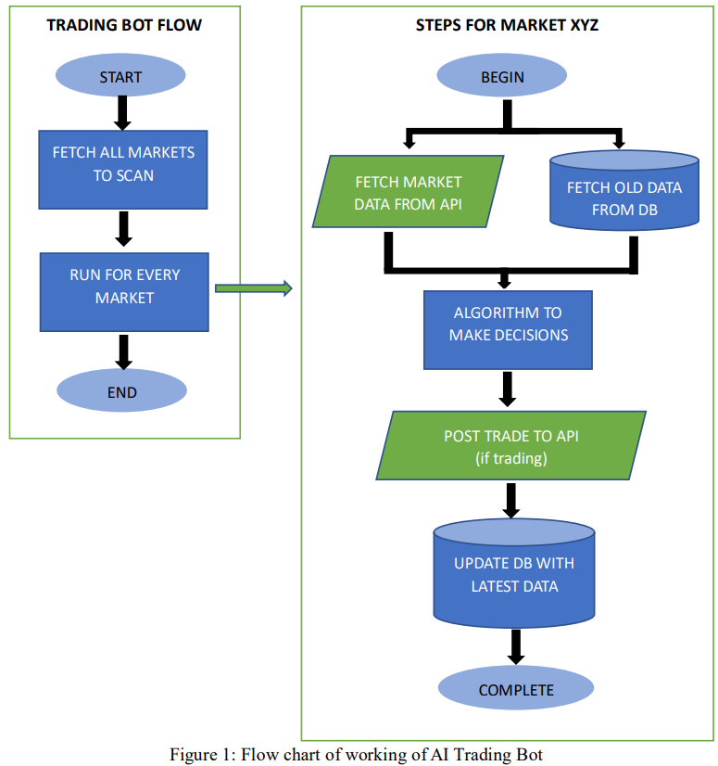

**Figure 1:** Flow diagram of the bot taking the real-time data and executing trades.

1. **RESULTS AND DISCUSSION**

The "AI Trading Bot" project aimed to develop an automated trading system using artificial intelligence algorithms. Key results include:

Fetching of Real-Time Data: This is done by selecting a specific stock present in the market and giving a time period through which the data should be fetched out for. And, with this a graph is also plotted using the python module plotly to see the stock as a graph that how the process of pricing of the stock has gone up or down over the specified period of time.

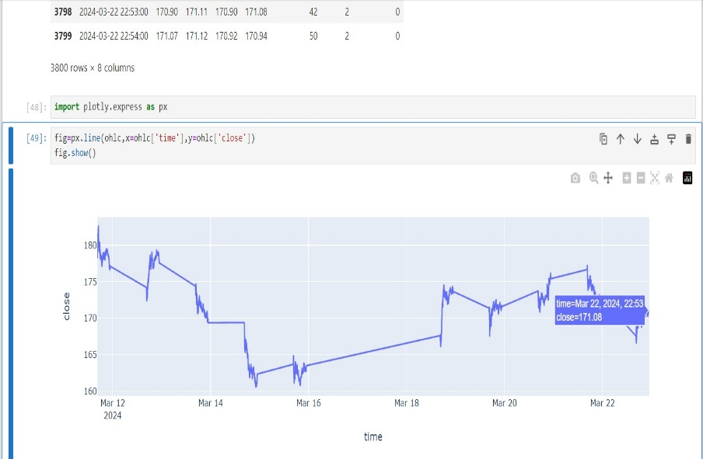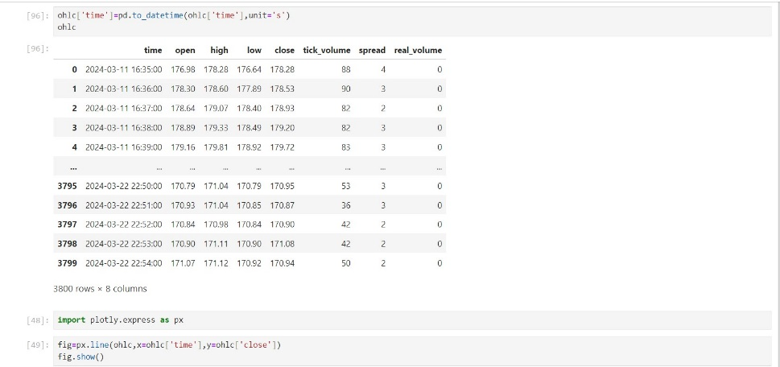

**Figure 2:** Fetching the real-time data **Figure 3:** Plotting the graph for the stock price

Buying and Selling of Stocks: The stock data fetched from the API is then analyzed by the bot, and it starts to buy or sell the trade by executing the trade functions possible depending on the conditions. The user can specify the profit percentage they want to go with and the loss percentage that can be afforded by the user for the stock. Then the user just needs to give a time period so that the bot executes the process automatically and according to the take profit or stop loss condition, the trades are executed automatically. This doesn’t require any manual interaction later on.

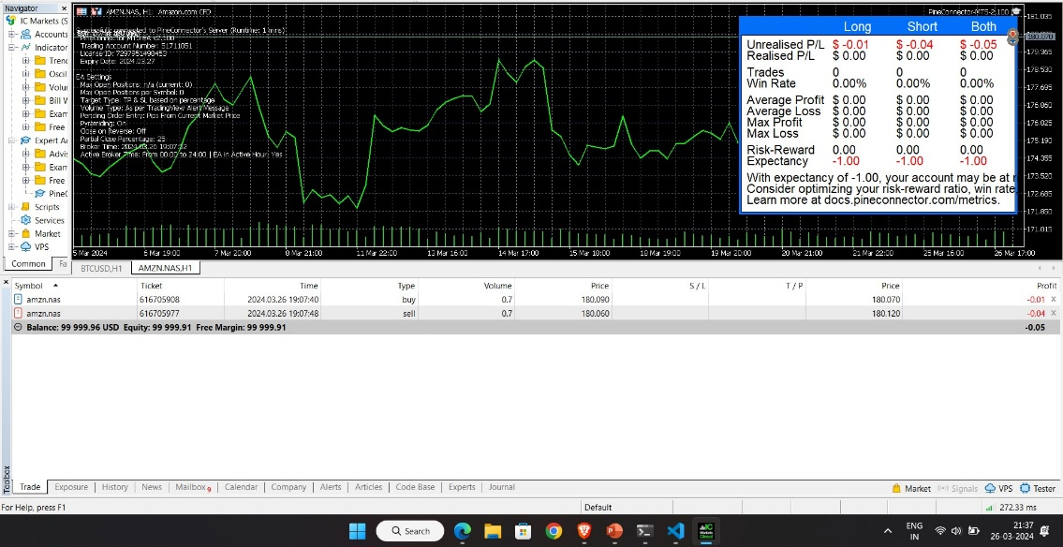

**Figure 4:** The Bot executing automatically in the market

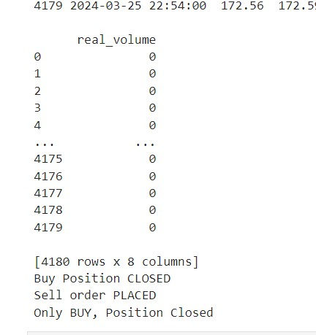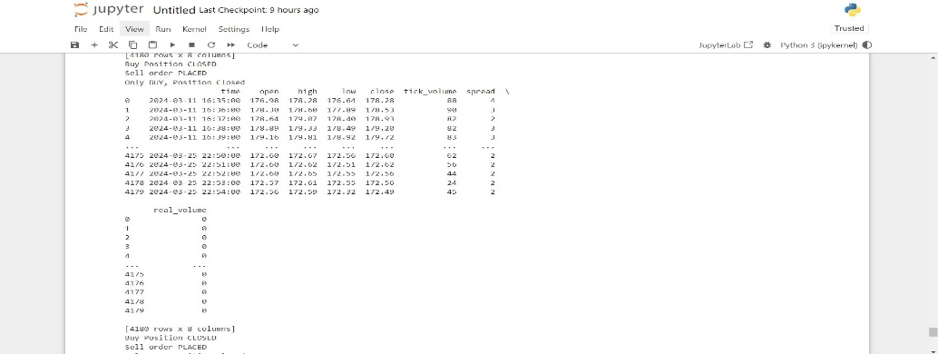

**Figure 5:** The execution of buy or sell done by the bot

1. **CONCLUSION**

In conclusion, the development and implementation of the AI Trading Bot project have yielded significant insights into the intersection of artificial intelligence and financial markets. Through rigorous research, programming, and testing, we have demonstrated the feasibility of using machine learning algorithms to analyze market data and make trading decisions autonomously.

The AI Trading Bot has shown promising results in terms of generating profits, mitigating risks, and outperforming traditional trading strategies in certain market conditions. However, it's essential to acknowledge the limitations and challenges encountered during the project, such as data quality issues, model overfitting, and market unpredictability. The automatic execution of trades makes it easy for a user and saves a lot of time.

Looking ahead, there are several avenues for further improvement and exploration. This includes refining the bot's algorithms, integrating additional data sources, enhancing risk management techniques, and exploring advanced machine learning methods such as deep learning. Additionally, ongoing monitoring and adaptation will be crucial to ensure the bot's continued effectiveness in dynamic market environments.

Overall, the AI Trading Bot project represents a significant step forward in leveraging artificial intelligence for financial trading. While there are still challenges to overcome, the potential benefits in terms of efficiency, accuracy, and profitability make this an area ripe for continued research and development.

1. **REFERENCES**
2. T. Arya Yudhi Wiiava, Chastine Fatichah, Ahmad Saikhu, “Stock Price Prediction with Golden Cross and Death Cross on Technical Analysis Indicators Using Long Short-Term Memory”,2022 5th International Conference on Information and Communications Technology (ICOIACT), Yogyakarta, Indonesia, Aug. 2022.
3. Xiaojian Weng, Xudong Lin, Shuaibin Zhao, “Stock Price Prediction Based On LSTM And Bert” 2022 International Conference on Machine Learning and Cybernetics (ICMLC), Japan, Sep. 2022,.
4. Xiao-Yang Liu, Zhuoran Xiong, Shan Zhong, Hongyang Yang, and Anwar Walid, “Deep Reinforcement Learning Approach for Stock Trading”, 2018
5. Gourav Bathla, “Stock Price prediction using LSTM and SVR,” 2020 Sixth International Conference on Parallel, Distributed and Grid Computing (PDGC), Waknaghat, India, Nov. 2020
6. Sparsha Vohra, P Savaridassan, “Stock Price Trend Analysis and Prediction of Closing Price Using LSTM”, 2023 International Conference on Computer Communication and Informatics (ICCCI), Coimbatore, India, Jan 2023.
7. Jiang et. Al., "An Ensemble Learning Framework for Algorithmic Trading", Mar 2019.
8. Salah Bouktif, Ali Fiaz, Mamoun Awad, “Augmented Textual Features-Based Stock Market Prediction”, IEEE-2020, Feb. 20, Vol 8, Pgs 40269 – 40282
9. Chun Yuan Lai, Rung-Ching Chen, Rezzy Eko Caraka, “Prediction Stock Price Based on Different Index Factors Using LSTM”, 2019 International Conference on Machine Learning and Cybernetics (ICMLC), Kobe, Japan, July 2019,
10. Isha, Shivadutt dixit, Manoj Kumar Ahirwar, Damam Sakethnath, Manik Rakha,”Stock Prediction by Analyzing the Past Market Trend”, 2021 9th International Conference on Reliability, Infocom Technologies and Optimization (ICRITO), Sep 2021
11. Chintan Vora, Dhairya Sheth, Bhavya Shah, Nasim Banu Shah, “Stock Price Analysis and Prediction”, 2021 International Conference on Communication information and Computing Technology (ICCICT), Mumbai, India, June 2021,
12. J. M. T. Wu, Z. Li, G. Srivastva, M. H. Tasi, and J. C. W. Lin, “A graph based convolutional neural network stock price prediction with leading indicators”, Software Practical Exper, 2020, pp. 117, Oct. 2020.